EXP NO:3A

TITLE:Create a prototype with familiar and unfamiliar navigation

elements. Evaluate ease of use with different user groups using proto.io

#### AIM:

The aim is to develop a prototype incorporating both familiar and novel navigation

elements and assess usability among diverse user groups using Proto.io.

#### PROCEDURE:

Step 1: Sign Up & Log In

Go to [proto.io](https://proto.io/)

Sign up or log in

Step 2: Create a New Project

Click "Create New Project"

Enter project name (e.g., "Simple App Example")

Select device type (e.g., iPhone X)

Click "Create"

Step 3: Design Home Screen

Add Screen: Click "+" → Select "Blank" → Name it "Home"

Add Elements:

Drag "Header" → Edit text to "Home Screen"

Drag "Button" → Edit text to "Go to Profile"

Add Interaction:

Select button → "Interactions" tab → "+ Add Interaction"

Trigger: Tap/Click, Action: Navigate to Screen → Create "Profile" screen

Step 4: Design Profile Screen

Add Elements:

Drag "Header" → Edit text to "Profile Screen"

Drag "Image" → Upload profile picture

Drag "Text" → Add profile info (e.g., "John Doe, Software Engineer")

Add Back Button:

Drag "Button" → Edit text to "Back to Home"

Add Interaction:

Select button → "Interactions" tab → "+ Add Interaction"

Trigger: Tap/Click, Action: Navigate to Home

Step 5: Preview & Share

Preview: Click "Preview" to test navigation

Share: Click "Share" → Copy link → Share for feedback

Top of Form

Bottom of Form

#### OUTPUTS:

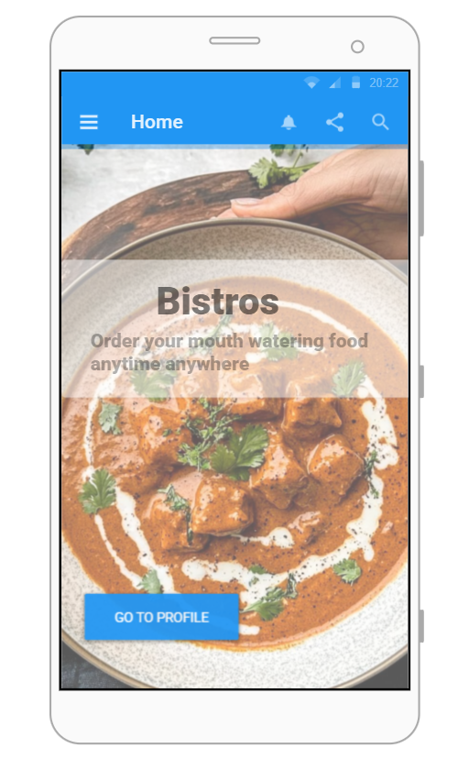

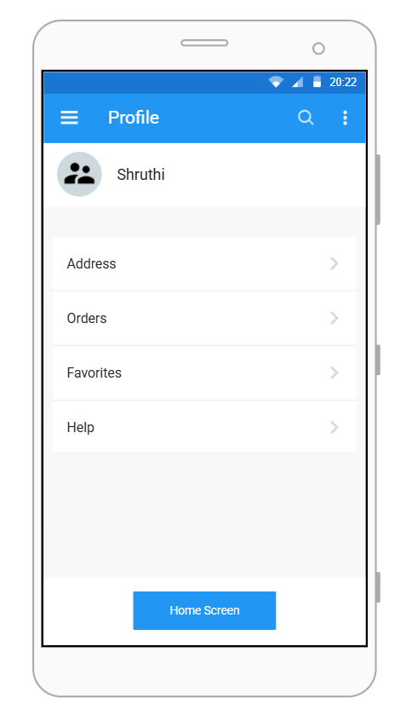

#### RESULT:

Successfully created an interactive prototype with a Home and Profile screen, implemented navigation using buttons, tested interactions using proto.io.

Link: https://pr.to/2GSLJI/